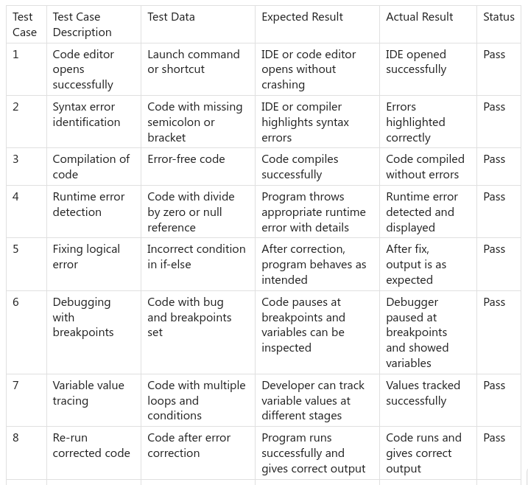
CPS 3: Junior software developer trying to fix the errors in the code and make it work correctly.

